Module title: Preparing cargo for transportation

Level: Intermediate

Duration: 4 weeks

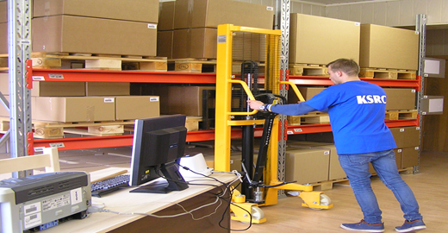
Learning Goals:

- To get basic understanding organizing logistics’ service;
- To introduce the innovations of the international logistics;
- To train the ability to prepare cargo for the transportation and storage;
- To carry out simple measurements of the cargo in the warehouse;
- To improve social skills.

Module elements:

- Safety at work;
- Receiving and issuing goods, preparing for the transportation;
- Preparing cargo for storage;
- Taking orders;
- Using IT and logistics programs;
- Working with customers.

Form:

- Short theoretical instructions/lectures:
- Theoretical lessons will be short and the majority of the activities will be practical and take place in the workshop area;
- The theoretical lessons will underpin the practical tasks and take place in digital environment.
- Practical work/workshop assignment:
- Training will be as an interaction between the theory and practice, focusing mainly on the practical tasks, working on the organisation of logistics service;
- Students will have one day practice at the school workshops followed by nineteen days practice at companies.

Pre-module qualifications:

- can speak and read English at level A2 -B2 (European reference);
- knows storage techniques;
- knows and can use the most common hand tools and equipment.

Assessment:
 | Knowledge | Skills | Competence
 | The student is able to:  - work safely;  - identify goods by container, types of packaging and labelling;  - fill order forms;  - find and select information;  - plan an international transport route, prepare documents;  - effectively communicate with customers;  - work in a team. | The student can:  - use IT and office equipment;  - use the warehouse equipment;  - manage accounting of warehouse logistics operations;  - work with clients;  - establish contacts with new people. | The student can:  - take an order;  - receive and to issue goods;  - look for the goods;  - prepare cargo for transportation and for storage;  - select the vehicle;  - communicate with clients.
Levels of assessment: | • Above Average.  • Average.  • Below Average.  • Not satisfactory. | • Above Average.  • Average.  • Below Average.  • Not satisfactory. | • Above Average.  • Average.  • Below Average.  • Not satisfactory.

